**SOFTWARE REQUIREMENT SPECIFICATION DOCUMENT**

# STUDENT MANAGEMENT

**Version:** Version 1.0

## ABSTRACT

This document is intended to be the SRS for developing **STUDENT MANAGEMENT SYSTEM**

|  |  |  |  |
| --- | --- | --- | --- |
| **Project Title** | **STUDENT MANAGEMENT** | | |
| **Lead Institution** | **International School** | | |
| **Project Mentor** | Mr.Nguyễn Đặng Quang Huy | | |
| **Team Name** | **Team 4** | | |
| **Team Members** | Lê Thị Thu Hương | | |
| Huỳnh Văn Tuấn | | |
| Phạm Hồng Thuận | | |
| Nguyễn Mạnh Vũ | | |
| Võ Thị Tú | | |
| **Start Date** | **2/10/2019** | End Date | **30/11/2019** |

**ROPRIETARY INFORMATION**: The information contained in this document is the property of **STUDENT MANAGEMENT**. Except as specifically authorized in writing by **STUDENT MANAGEMENT**, the holder of this document shall keep all information contained herein confidential and shall protect same in whole or in part from disclosure and dissemination to all third parties.

Software Requirement Specification Version 1.0

# Table of Contents

Revision History 4

1. Introduction 5
   1. Purpose 5
   2. Intended Audience and Reading Suggestions 5
   3. References 5
2. Project Overview 6
   1. Project Description 6
   2. Business Need 6
   3. Project Analyst 6
      1. Business Function Diagram 6
      2. System Context Diagram 6
      3. Data Flow Diagram 6
   4. Software Requirement Specification 6
      1. High level Fucntional Requirement (FR) 6
      2. Stakeholders 6
      3. Usecase 7
         1. <<project name>> Use Case Diagram Overview 7
      4. List of use cases 7
      5. List of business rule 8
      6. Use Case Specification 9

UC 01: Create a New Place 9

UC 02: Edit a Place’s Information 11

* + 1. Software Quality Attributes 13
       1. Usability 13
       2. Reliability 14
       3. Security 14
       4. Maintainability 15
       5. Portability 15
       6. Performance 15
  1. Software Design Description 16
     1. Sequence Diagrams 16
        1. Cập nhật thông tin nhân viên 16
        2. Quan hệ Gia đình 17
     2. Activity Diagrams 18
        1. Cập nhật thông tin nhân viên 18
     3. State Diagram 18
     4. Class Diagram 19
     5. Allocation Diagram 19

Appendix A: Glossary 19

# Revision History

|  |  |  |  |  |
| --- | --- | --- | --- | --- |
| **Date** | **Change Iterm** | **Description** | **by** | **Version** |
|  |  |  |  |  |
|  |  |  |  |  |
|  |  |  |  |  |
|  |  |  |  |  |
|  |  |  |  |  |
|  |  |  |  |  |
|  |  |  |  |  |
|  |  |  |  |  |
|  |  |  |  |  |
|  |  |  |  |  |

# Introduction

## Purpose

This documentation describes a student management system including all needed information and feature materials in detail for implementation. The purposes of this document are as below:

* + - To supports the project manager having an overview of the system as well as doing project estimation
    - To describes the architectural drivers and use cases in details. Based on this document, architect analyst and designer will be able to implement the system easily.
    - To supports tester (QC) writing acceptance test and test plan.

## Intended Audience and Reading Suggestions

|  |  |
| --- | --- |
| **Intended Audience** | **Reading Suggestions** |
| Project manager | High level functional requirement, business constraints for estimation |
| Architect analyst and designer | Overall description and user cases to architect and design the system |
| Quality control | Overall description and user cases to make test plan and write acceptance test |
|  |  |

## References

# Project Overview

## Project Description

## Duy Tan University receives a number every year large student population. One of the difficulties that the school's training room The problem is student management, not just new students admission but also many students are currently studying at the school, the management This is most difficult in the final and final semester sessions year. Therefore, the requirement of the school is to have a student management department, of each class as well as of each department so that no errors can be made. in the process of managing students of the school.

* Track the entire learning process of students during the learning process.
* School from admission to graduation, make sure no errors occur in too course of updating information and statistical information of students. This system helps the training room follow track and evaluate student results in the fastest and most accurate way. It will greatly reduce the effort and paperwork. archive books.
* In addition to updating each student's information, the system can also look up a number Necessary information about students, related papers, ...
* The system of storing and processing information of each student according to the school's regulations.
* Statistical control of reward and discipline Students quickly and accurately. Through management work that is possible have specific records of students' academic results upon graduation.

Đại học Duy Tân nhận được số lượng sinh viên lớn mỗi năm. Một trong những khó khăn mà phòng đào tạo của trường là vấn đề quản lý học sinh, không chỉ nhập học sinh mới nhưng cũng có nhiều sinh viên đang học tại trường, quản lý điều này là khó khăn nhất trong năm học kỳ cuối cùng và cuối cùng . Vì vậy, yêu cầu của trường là phải có một bộ phận quản lý sinh viên, của mỗi lớp học cũng như của mỗi bộ phận để không có lỗi có thể được thực hiện. trong quá trình quản lý sinh viên của trường.

• Theo dõi toàn bộ quá trình học tập của học sinh trong quá trình học tập

• Trường từ nhập học để tốt nghiệp, đảm bảo không có lỗi xảy ra trong quá trình cập nhật thông tin và thông tin thống kê của sinh viên. Hệ thống này giúp phòng đào tạo theo dõi và đánh giá kết quả của sinh viên theo cách nhanh nhất và chính xác nhất. Nó sẽ làm giảm đáng kể nỗ lực và giấy tờ. sách lưu trữ.

• Ngoài việc cập nhật thông tin của mỗi học sinh, Hệ thống cũng có thể tìm kiếm một số thông tin cần thiết về sinh viên, giấy tờ liên quan,...

• Hệ thống lưu trữ và xử lý thông tin của mỗi học sinh theo quy định của trường.

• Kiểm soát thống kê các phần thưởng và kỷ luật học sinh nhanh chóng và chính xác. Thông qua công việc quản lý có thể có hồ sơ cụ thể về kết quả học tập của học sinh sau khi tốt nghiệp.

## Business Need

**Customers need a student management system.**

* + Student records management.
  + Update student records.
  + Update training program.
  + Management reward and discipline.
  + Manage related papers.

Khách hàng cần một hệ thống quản lý học sinh.

o quản lý hồ sơ học sinh.

o Cập nhật hồ sơ học sinh.

o Cập Nhật chương trình đào tạo.

o phần thưởng và kỷ luật quản lý.

o quản lý giấy tờ liên quan

## Project Analyst

* + 1. **Business Function Diagram**

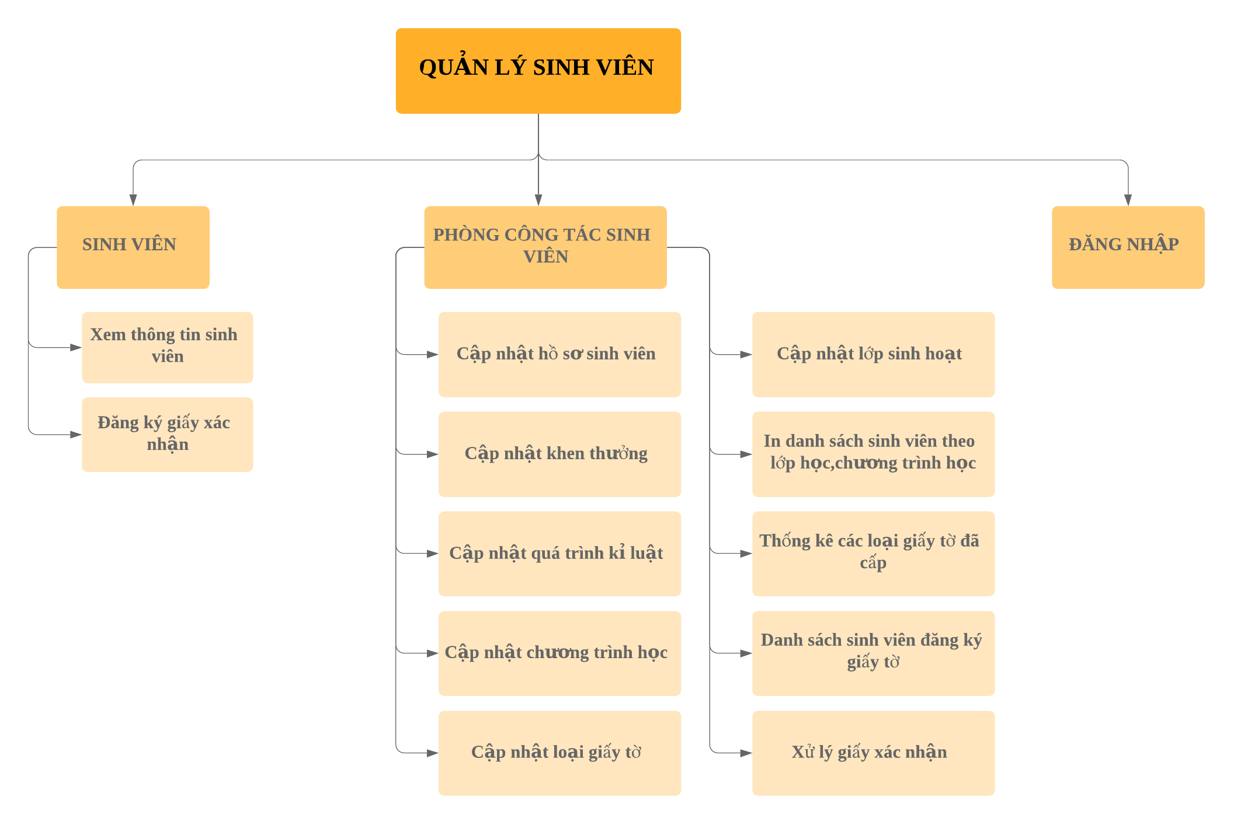**2.3.2.System Context Diagram**

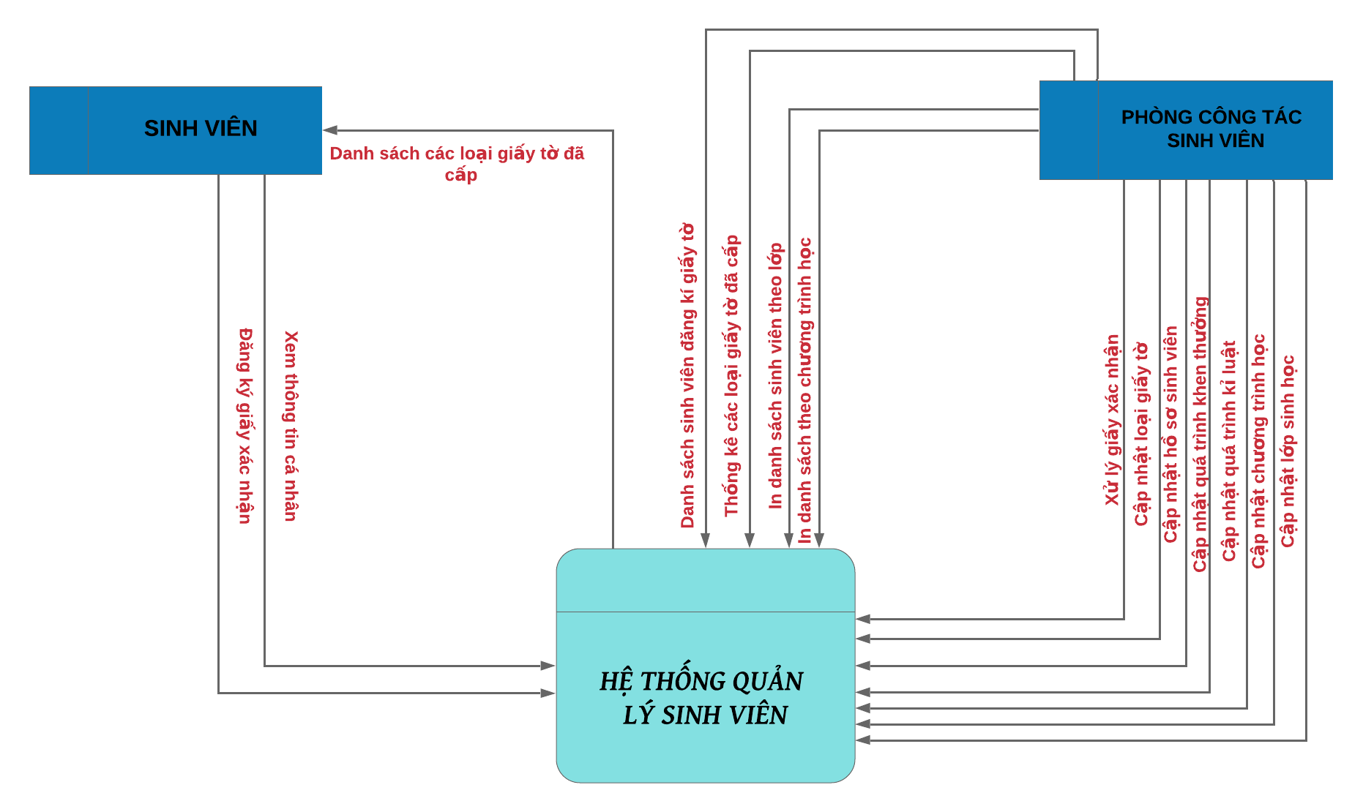

**2.3.3.Data Flow Diagram:**

Data flow model at level 2

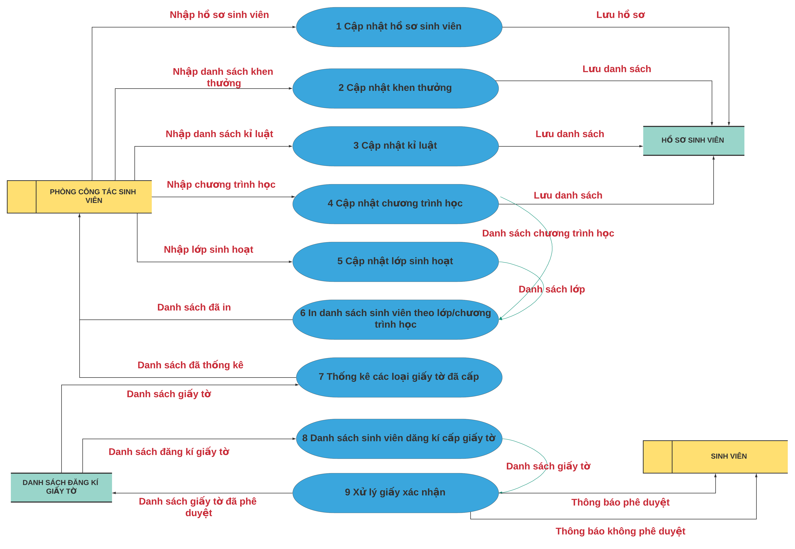

## Software Requirement Specification

## High level Fucntional Requirement (FR)

|  |  |  |
| --- | --- | --- |
| FR1.1 | **Title** | **Create and check account** |
| Stakeholder | Users who use jukebox for playing music |
| Description | If user is new one, the system will allow him/her establish an account and specify  amount the money that he/she allocate from their credit card into Jukebox account. Otherwise, user can check Jukebox balance. |
| FR1.2 | Title | **Select & play music** |
| Stakeholder | Users who use jukebox for playing music |
| Description | The system shall display list of songs grouped into music genres and will allow user select music genres and songs to play. Once the first song is selected the song will start playing while allowing user to make further choices. The system shall also record such selected and played song into database. User can deselect his/her songs from the current playlist and amount of deselecting shall refund. User can create account on one Jukebox and play music on another in distributed  system. |

## Stakeholders

|  |  |
| --- | --- |
| **Stakeholder** | **Description** |
| Users | People who use jukeboxes to play music |
| System administrators | People who administer and configure the jukebox system |
| Engineer | Person who deploy the Jukebox System |

## Usecase

## <<Student Management System >> Use Case Diagram Overview

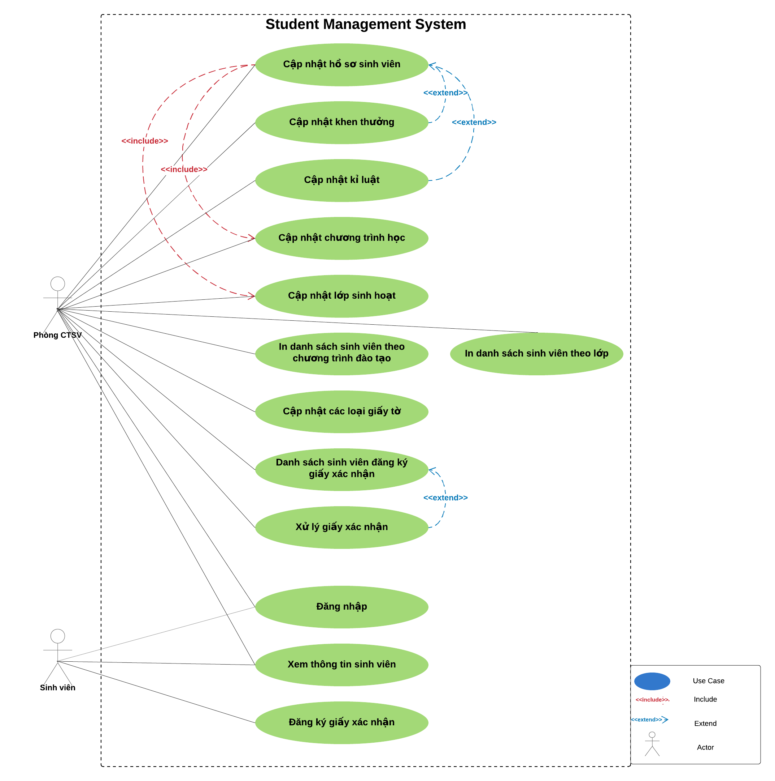

## List of use cases

|  |  |  |
| --- | --- | --- |
| **Use case ID** | **Use case name** | **Functional Req.** |
| UC.01 | Login | FR.1 |
| UC.02 | View student Information | FR.2 |
| UC.03 | Sign up for Certification | FR.3 |
| UC.04 | Update Student Profiles | FR.4 |
| UC.05 | Reward updates | FR.5 |
| UC.06 | Disciplinary updates | FR.6 |
| UC.07 | Program Update | FR.7 |
| UC.08 | Update the Living class | FR.8 |
| UC.09 | Print a list of students according to the training program | FR.9 |
| UC.10 | Update papers | FR.10 |
| UC.11 | List of students registered for certification | FR.11 |
| UC.12 | Handling of confirmation paper | FR.12 |

## List of business rule

|  |  |  |
| --- | --- | --- |
| **Code** | **Business rules** | **Use case** |
| BR1 | Rank of a user will be se based on the user’s contribution point (CP) | UC.02 |
| BR2 | Contribution Point (CP) is calculated as follow:   * Starter point for every user is 10 point * Create a place: + 20 point * Your place get deleted: ‐ 25 point | UC.02 |
| BR3 | For user has more than 1000 point (senior user):   * Can edit a place directly * Can upload place’s image directly * Can approve suggested edit * Can approve suggested images * Set a revision as current | UC. 02 |
| BR4 | For user has less than 1000 point (junior user):  ‐ an revision of a place created by these users  need approvals from senior users or admins to be displayed | UC.02 |

* + 1. **Use Case Specification**

### UC 01: Login

1. Use Case Diagram

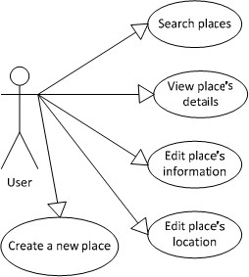

1. Use Case Specìication

|  |  |  |  |  |  |
| --- | --- | --- | --- | --- | --- |
| Use case ID | **UC1.01** | | | | |
| Use case name | **Login** | | | | |
| Create by | Thuan | | Thuan | | Thuan |
| Date created | Oct 26, 2019 | | Oct 26, 2019 | | Oct 26, 2019 |
| Actor | Engineer | | | | |
| Description | This use case allows the user to activate the system | | | | |
| Trigger | Click to “**Đăng nhập**” in navigator at home page | | | | |
| Pre-condition | User logged into the system successfully. | | | | |
| Post-condition | The system displays a login form asking for information. | | | | |
| Main Success  Scenario: | **Step** | **Actor Action** | | **System Response** | |
| 1 | Click to “**Đăng nhập**” in navigator at home page | | Redirect to Login | |
| 2 | Fills all mandatory data fields | |  | |
| 3 | Click to “**Đăng nhập**” button. | | Redirect to login form | |
| Alternative Scenario | **Step** | **Actor Action** | | **System Response** | |
| 1 | Click to “**Đăng nhập**” in navigator at home page | | Redirect to Login | |
| 2 | Fills all mandatory data fields | |  | |
| 3 | Click to “**Bỏ Qua**” button. | | Redirect to new place’s details page. | |
| Exceptions | **Step** | **Actor Action** | | **System Response** | |
| 1 | Click to “**Đăng nhập**” in navigator at home page | | Redirect to Login | |
| 2 | User fills some data fields. Some mandatory data fields are skipped. | |  | |
| 3 | Click to “**Đăng nhập**” button. | | Shows all required messages for all missing mandatory data fields. | |
| Priority | High | | | | |
| Business rule | N/A | | | | |
| Description: | when users want to search or view student information they just need to press "Login". To log in users need to enter their username / password.   * Account name: required, over 7 characters. * password: required, must be over 8 characters, with numbers and special characters.   When the user clicks to the "Login" button, the system will open the Login page. By clicking to "Huy" button, the user will go back to previous page. | | | | |

1. Prototype

### UC 01: Search

1. 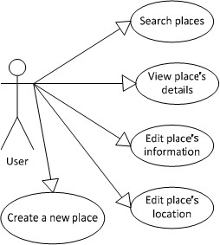Use Case Diagram
2. Use Case Specìication

|  |  |  |  |  |  |
| --- | --- | --- | --- | --- | --- |
| Use case ID | **UC1.01** | | | | |
| Use case name | **Search** | | | | |
| Create by | Thuan | | Thuan | | Thuan |
| Date created | Oct 26, 2019 | | Oct 26, 2019 | | Oct 26, 2019 |
| Actor | Engineer | | | | |
| Description | This function allows users to search | | | | |
| Goal | Click to “**Tìm kiếm**” in navigator at home page | | | | |
| Trigger | User logged into the system successfully. | | | | |
| Pre-condition | The system will display a frame for users to search | | | | |
| Post-condition | **UC1.01** | | | | |
| Main Success  Scenario: | **Step** | **Actor Action** | | **System Response** | |
| 1 | Click to “**Tìm kiếm**” in navigator at home page | | Redirect to Search | |
| 2 | Fills all mandatory data fields | |  | |
| 3 | Click to “**Tìm kiếm**” button. | | Redirect to search form | |
| Alternative Scenario | **Step** | **Actor Action** | | **System Response** | |
| 1 | Click to “**Tìm kiếm**” in navigator at home page | | Redirect to Search | |
| 2 | Fills all mandatory data fields | |  | |
| 3 | Click to “**Xóa thông tin tìm kiếm**” button. | | Redirect to new place’s details page. | |
| Exceptions | **Step** | **Actor Action** | | **System Response** | |
| 1 | Click to “**Tìm kiếm**” in navigator at home page | | Redirect to Login | |

|  |  |  |  |
| --- | --- | --- | --- |
|  | 2 | User fills some data fields. Some mandatory data fields are skipped. |  |
| 3 | Click to “**Tìm kiếm**” button. | Shows all required messages for all missing mandatory data fields |
| Priority | High | | |
| Business rule | N/A | | |
| Description: | When users want to search, they just need to press "Search". To search users, enter name, class, id, science ...  • The user name, id, class, department must be entered  When the user clicks on the "Search" button, the system will open a new form. By clicking the "clear search information" button, users will search for new students | | |

1. Prototype

### UC 01: Watch information

1. Use Case Diagram



1. Use Case Specìication

|  |  |  |  |  |  |
| --- | --- | --- | --- | --- | --- |
| Use case ID | **UC1.01** | | | | |
| Use case name | **Watch information** | | | | |
| Create by | Thuan | | Thuan | | Thuan |
| Date created | Oct 26, 2019 | | Oct 26, 2019 | | Oct 26, 2019 |
| Actor | Engineer | | | | |
| Description | This function allows users to watch information | | | | |
| Trigger | Click to “**Xem thông tin**” in navigator at home page | | | | |
| Pre-condition | User logged into the system successfully. | | | | |
| Post-condition | The system will display student information view and training information view | | | | |
| Main Success  Scenario: | **Step** | **Actor Action** | | **System Response** | |
| 1 | Click to “**Xem thông tin**” in navigator at home page | | Redirect to watch information | |
| 2 | Fills all mandatory data fields | |  | |
| 3 | Click to “**Chương trình đào tạo**” button. | | Redirect to educatetion program | |
| Alternative Scenario | **Step** | **Actor Action** | | **System Response** | |
| 1 | Click to “**Xem thông tin**” in navigator at home page | | Redirect to watch information | |
| 2 | Fills all mandatory data fields | |  | |
| 3 | Click to “**Thông tin sinh viên**” button. | | Redirect to student information | |
| Exceptions | **Step** | **Actor Action** | | **System Response** | |
| 1 | Click to “**Xem thông tin**” in navigator at home page | | Redirect to watch information | |
| 2 | User fills some data fields. Some mandatory data fields are skipped. | |  | |
| 3 | Click to “**Xem**” button. | | Shows all required messages for all missing mandatory data fields. | |
| Priority | High | | | | |
| Business rule | N/A | | | | |
| Description: | when the user clicks on "" the system asks the user to choose to view training or student information.  When the user selects a training program, the system displays the training program frame.  When the user selects student information, the system will display all student information stored in the system | | | | |

### UC 01: Student management

1. Use Case Diagram



1. Use Case Specìication

|  |  |  |  |  |  |
| --- | --- | --- | --- | --- | --- |
| Use case ID | **UC1.01** | | | | |
| Use case name | **Login** | | | | |
| Create by | Thuan | | Thuan | | Thuan |
| Date created | Oct 26, 2019 | | Oct 26, 2019 | | Oct 26, 2019 |
| Actor | Engineer | | | | |
| Description | This function allows users to student management | | | | |
| Trigger | Click to “**Quản lí sinh viên**” in navigator at home page | | | | |
| Pre-condition | User logged into the system successfully. | | | | |
| Post-condition | The system will display student management, grades, statistics | | | | |
| Main Success  Scenario: | **Step** | **Actor Action** | | **System Response** | |
| 1 | Click to “**Quản lí sinh viên**” in navigator at home page | | Redirect to student management | |
| 2 | Fills all mandatory data fields | |  | |
| 3 | Click to “**Quản lí thông tin sinh viên**” button. | | Redirect to student information | |
| Alternative Scenario | **Step** | **Actor Action** | | **System Response** | |
| 1 | Click to “**Quản lí sinh viên**” in navigator at home page | | Redirect to student management | |
| 2 | Fills all mandatory data fields | |  | |
| 3 | Click to “**Quản lí lớp học**” button. | | Redirect to classroom list | |
| Exceptions | **Step** | **Actor Action** | | **System Response** | |
| 1 | Click to “**Quản lí sinh viên**” in navigator at home page | | Redirect to student management | |
| 2 | User fills some data fields. Some mandatory data fields are skipped. | |  | |
| 3 | Click to “**Quản lí thông kê**” button. | | Shows to tuhe list has statistics | |
| Priority | High | | | | |
| Business rule | N/A | | | | |
| Description: | When users choose to manage students. The system displays student information management, classroom information management, statistical management.  When the user selects 1 of 3, the system will display the information that the user needs | | | | |

**GUI**

* + 1. **Software Quality Attributes**
       1. **Usability**
          - All the text, image text and help documents should be in Vietnamese.
          - The interface should be elegant, simple and out‐standing.
          - All images must also provide alt attribute.

## Usability for end‐users

* + - * + Searching tool should be easy to use.
        + The website must provide a help page to support novice users.
        + Users can use main functionality of the system without logging in to the system.
        + The system should remember information (but not confidential) that users have to provide regularly. For example: name, address…

## Usability for admin and staff

* + - * + Website admin and shop’s staff should need no more than one day of training to be productive with the system.
        + Detailed help must be available for the admin and staff, both in web pages and separate documentations.

## Installation

* + - * + The system must be easy to deploy. Customer can deploy successfully and learn to configure, maintain the system within one day of training.
        + The documentation for installation must be included. It describes detailed steps for installing or deploying the system. The customer can follow the steps without direct help from the developing team.

## Reliability

* Initial data must be collected carefully and correctly
* The database must be backed up regularly and can be recovered if necessary
* Have a good spam filter
* Rating system must be reliable
* Not conflict with other software
* Rate of fault occurrence (ROFO): a number of 0.005 is acceptable. It means that it is acceptable to have 5 failures happen in each 1000 operational time units (e.g. 5 failures per 1000 hours of operation).
* Mean Time Between Failures (MTBF): 1 month
* Mean Time To Repair (MTTR): immediately when admin finds out problem or website is attacked by someone. Average 1 day.
* Accuracy: precision of floating number should be rounded to 0.01. All currency units must be displayed (e.g. $, VND…)
* Maximum Bugs or Defect Rate: 5 bugs / KLOC.
* Bugs or Defect Rate
  + Minor bugs: bugs related to GUI
  + Significant bugs: bugs related to minor business logic
  + Critical bugs: function can’t execute correctly, completely loss of data, disconnect to the server

## Security

* Privacy: the system should provide protection method for protecting user information from outside or from other users. All the information of users must not be available for anyone or software that is not part of the system. User password is also invisible for the system administrator.
* The system must provide methods to prevent common security attacks. E.g. SQL injection, Ddos,…
* Transformation of confidential information must be encrypted.
* The system must provide secure methods for users to recovery their password, including the interference of system’s admin.
* Secure information of customers should not be stored on customer’s machine.
* Utilize certain cryptographic techniques for database
* Provide options for users to choose whether to share private information
* Restrict communications between some areas of the program
* Check data integrity for critical variables
* Must use secure connection (SSL) for transferring sensitive data

## Maintainability Coding standards and naming conventions

* Output of the project must include coding standards and naming conventions documentations. Implementation code must be easy to maintain.
* All code must be clearly commented, including class, method documentations.
* If some components are reused, the documentations of those components must also be included.

## Design

* The design of the system must be loosely coupled that chances on some module will not affect others.

## Logging

* All the errors should be logged, supporting for bug fixing and maintenance.
* All strange or sensitive situations should also be logged.

## Email

* The system must provide an email address to receive customer feedback or send emails.

## Portability

Website can be used by any people with a browser and an Internet connection..

## Performance

**Load time**

* Every page should be completely displayed within: average 1.5 second and maximum 5 seconds.
* Searching should return and display the result within 2 seconds.
* Comments and rating and the like should affect immediately, without reloading the web page.
* Frequently accessed data must be cached
* Reference data must be cached

## Mailing system

* Mail server should send emails within 1 minute after associated events happen.

## Capacity

* The system should serve correctly and reasonably with at least 1000 online users at a moment.
* The system can store at least 100000 places and 10000 users without affecting the loading speed.
* If the system is busy, it has to inform users about that.

## Compatibility

* The system should provide elegant responses for nowadays common screen resolutions: 1024*768, 1280*800.
* The output must be compatible with all common browsers: Mozilla Firefox, Internet Explorer, Google Chrome, Apple Safari, and Opera.

## Software Design Description 2.5.1.Sequence Diagrams

## Biểu đồ tuần tự đăng nhập

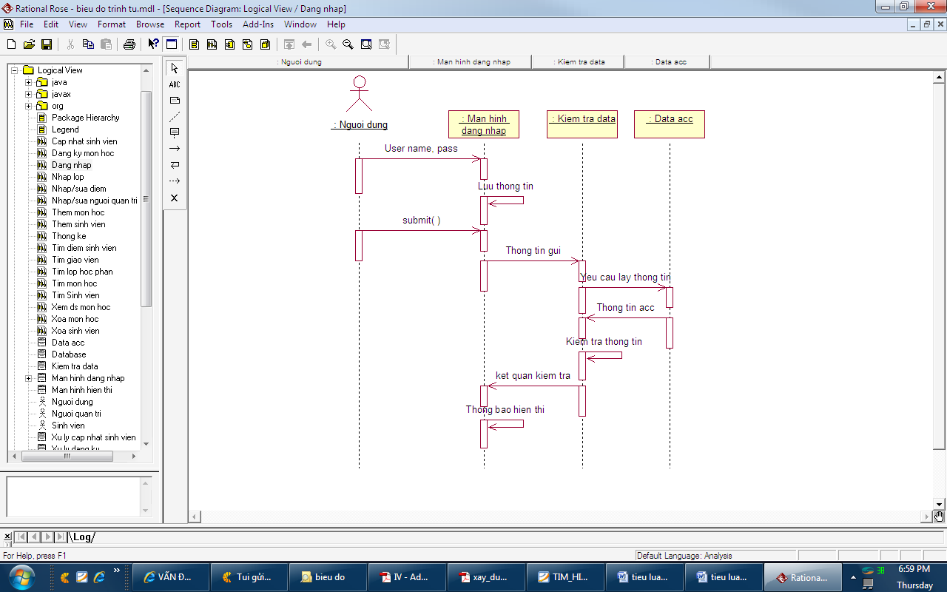

## Biểu đồ tuần tự tìm sinh viên

## Biểu đồ tuần tự nhập sửa thông tin

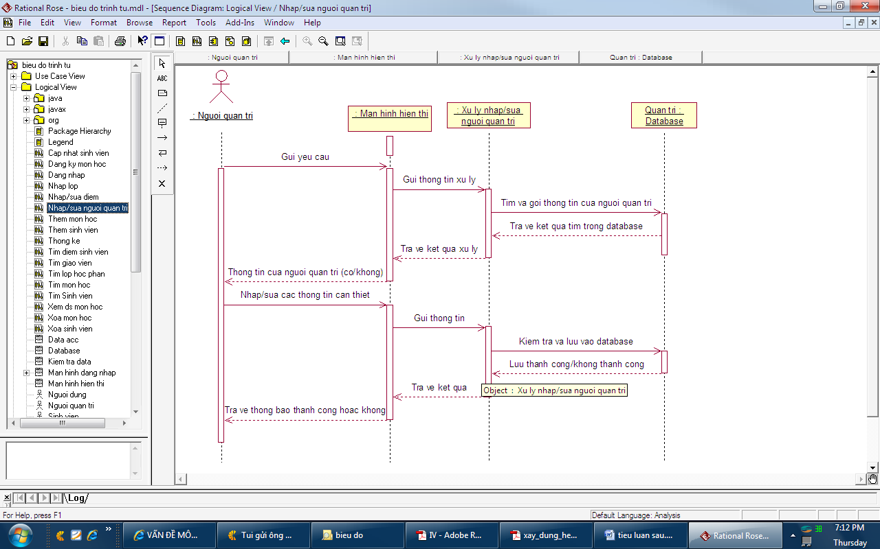

## Biểu đồ tuần tự thêm sinh viên

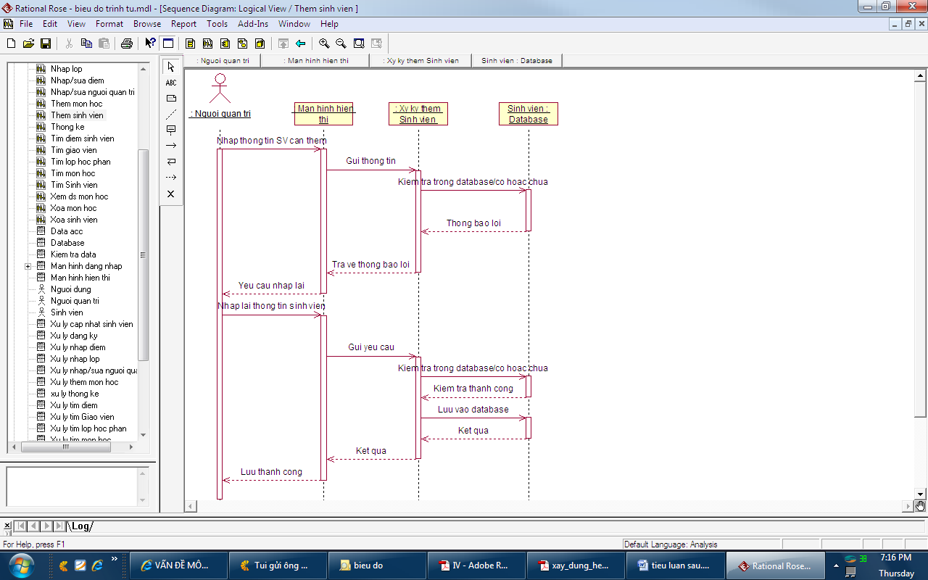

## Biểu đồ tuần tự xóa sinh viên

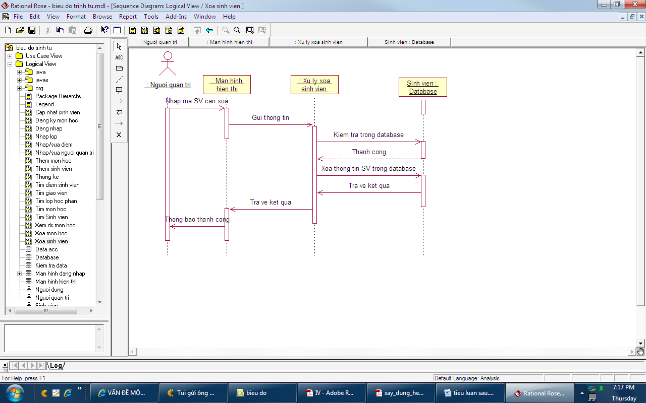

## Biểu đồ tuần tự thống kê

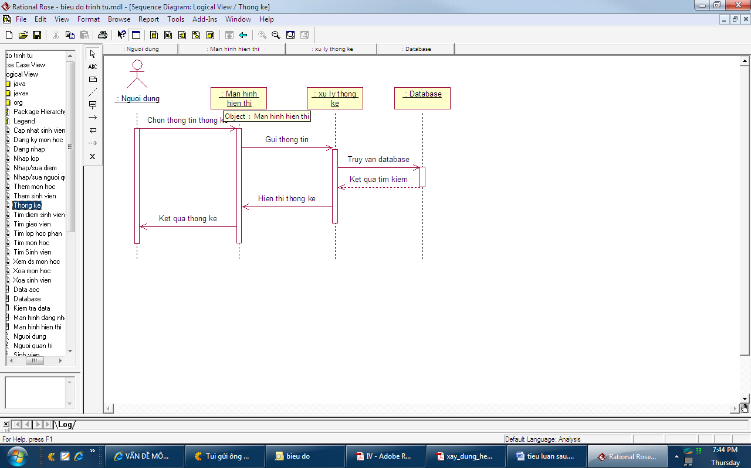

## Activity Diagrams

## Cập nhật thông tin nhân viên

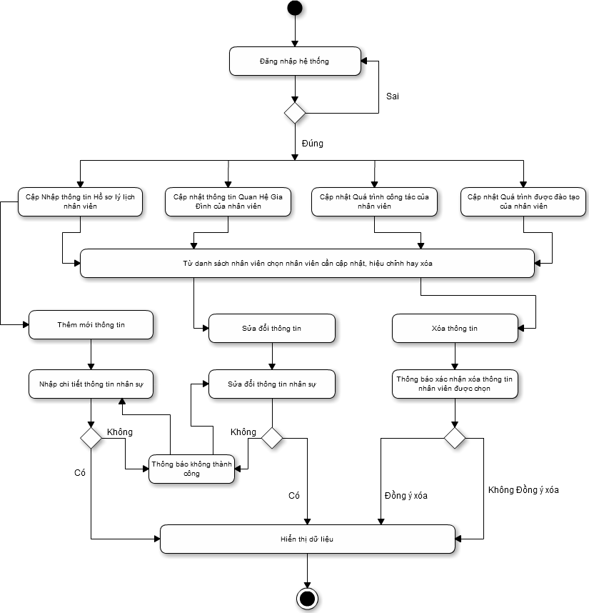

## State Diagram

## Class Diagram

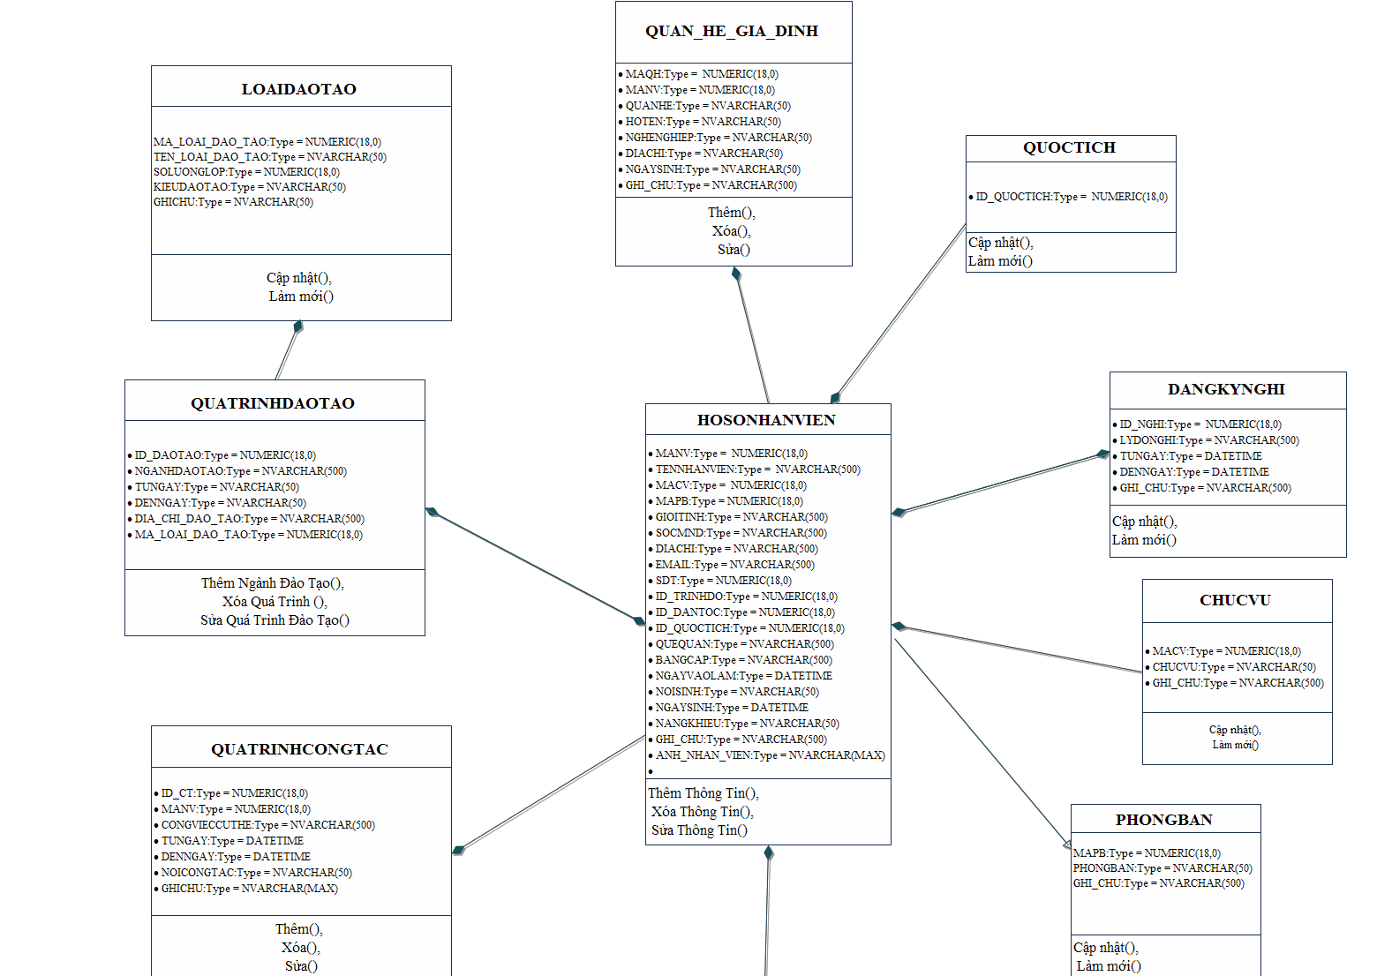

## Allocation Diagram

# Appendix A: Glossary

|  |  |
| --- | --- |
| BC | Business Constraint |
| TC | Technical Constraint |
| FR | Functional Requirement |
| QA | Quality Attribute |
| UC | Use case |
| BR | Business rule |